Quotestream RTD (Real-Time Data)

How to Use RTD?
Data Point Coverage
Data Point Format
System Requirements
Troubleshooting
Frequently-Asked Questions (FAQ)

Quotestream’s RTD functionality allows you to stream dynamic, real-time quote data to MS Excel spreadsheets in the Windows operating system.

This powerful tool greatly extends your control, whether you simply prefer to view live market data in a spreadsheet, or wish to perform specialized calculations and use specific Excel features such as charting, data aggregation, conditional formatting, macros, etc. As data updates in Quotestream, the same data updates accordingly in your spreadsheet, embedded in streaming real time.

With Quotestream RTD, you can track a wide range of stock market statistics, from basic stock quote data (last price, volume, change, bid, ask) to price statistics (52-week high, 52-week low) and valuation parameters (earnings per share, PE ratios, dividend yields). Data for up to 500 symbols is supported.

Having troubles connecting to the service?
Please see further on in this document for trouble shooting tips.

How to use RTD?

Using Quotestream RTD is easy. After logging on to Quotestream, open a new Excel workbook and enter an RTD function as follows:

=RTD("quotestream.rtdserver",,"MSFT:US","Last")
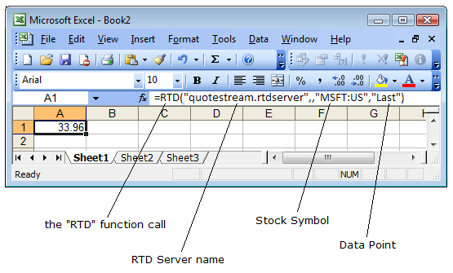

There are 4 parts to an RTD function:

- RTD Function Call – this is how Excel knows that you are calling an RTD function.

- RTD Server Name – the name of the RTD server where the function gets processed. In this case, the value is always "quotestream.rtdserver".

- Stock Symbol – a symbol of a stock or other financial instrument.

Note: Symbols containing an @ (ie - options symbols) must be escaped with a single quote.
For example, @APVIN needs to be entered into Excel as '@APVIN

- Data Point – the data point you wish to request (see “Data Points” further on in this document).

Note the two commas that come after the RTD server name and the single comma that comes after the stock symbol.

You can build your RTD spreadsheets from scratch by manually inputting RTD functions to an Excel spreadsheet. Alternatively, you can simply use one of several pre-defined RTD Excel spreadsheets we can provide for you, and customize it to your needs.

You can download Sample RTD Excel Spreadsheets from this web page:

http://www.quotestreampro.com/RTDdocs

Data Point Coverage

Quotestream DDE supports the following data points:
Last Price | Volume | Close Price | Currency
Change | Trade Value | Open Price | Dividend
Percent Change | VWAP | 52 Week High | Yield
Bid Price | Last Trade Time | 52 Week Low | Ex-Div
Bid Size | Last Trade Size | 52 Week High Date | Earnings Per Share
Ask Price | High | 52 Week Low Date | PE Ratio
Ask Size | Low | Previous Close | P/B Ratio
TRIV (TSX Indices) | Marketplace | TWAP | Shares Outstanding
Symbol | Tick | Description | Market Cap
Average Volume 10 Day | Tick Volume | Pre Market Last | Exchange
Average Volume 20 Day | Performance 3 Month | Pre Market Change | Post Market Last
Average Volume 30 Day | Performance 1 Month | Pre Market Percent Change | Post Market Change
Average Volume 50 Day | Performance 6 Month | Post Market Percent Change | Pre Market Volume
Average Volume 90 Day | Performance 1 Year | Pre Market Trade Time | Post Market Volume
Average Volume 100 Day | Sector | Post Market Trade Time | Industry
Average Volume 365 Day | Alpha | Beta | R-Squared
Standard Deviation | YTD% | Short Sale Restriction | SubIndustry
Performance 3 Year Annualized | Performance 3 Year Cumulative | Performance 5 Year Annualized | Performance 5 Year Cumulative
Performance 10 Year Annualized | Performance 10 Year Cumulative | Implied Volatility | Implied Volatility Change
21 Day Moving Average | 50 Day Moving Average | 200 Day Moving Average | Open Interest
Mark | Previous Mark | Mark Change Percent | Mark Change
Intrinsic Value | Extrinsic Value | Bid Implied Volatility | Ask Implied Volatility
Delta | Gamma | Theta | Vega
Rho | Enterprise Value | Return on Capital | Return on Equity
Return on Assets LTM | Return on Capital LTM | Return on Equity LTM | Return on Assets
Return on Invested Capital QTR | Return on Invested Capital 1YR | Post | Panel
Firm Name | Next Earnings Date | Earnings Quarter End | Settlement Date
Short Position | Avg Daily Volume | Short Interest Ratio | Short Interest change
Short Interest % change

Data Points

Data Points are available in long or short form for your convenience. Either may be used.

For example:

=RTD("quotestream";"MSFT:US";"Last Trade Time")

… will return the same result as…

=RTD("quotestream";"MSFT:US";"LTime")

Long Name | Short Name | Long Name | Short Name
Symbol | Symbol | Description | Desc
Last Price | Last | Change | Chg
Percent Change | PChg | Last Trade Time | Ltime
Last Trade Size | LSize | Bid Price | Bid
Ask Price | Ask | Ask Size | Asize
Bid Size | Bsize | Open Interest | Int
Volume | Vol | 52 Week High | 52wHi
Yield | Yld | 52 Week Low | 52wLo
Dividend | Div | Ex-Div | ExD
Earnings Per Share | EPS | PE Ratio | PER
P/B Ratio | PBRAT | Exchange | Exch
Marketplace | Market | Currency | Curr
Tick | Tick | Low | Lo
Open Price | Open | High | Hi
Previous Close | Pclose | Close Price | Close
TRIV | TRIV | Shares Outstanding | SHOS
Market Cap | MCap | Volume Weight Average Price | VWAP
TWAP | TWAP | Pre Market Last | PreLast
Pre Market Change | PreChg | Pre Market Percent Change | PrePChg
Pre Market Volume | PreVol | Pre Market Trade Time | PreLtime
Post Market last | Post Last | Post Market Change | PostChg
Post Market Percent Change | PostPChg | Post Market Volume | PostVol
Post Market Trade Time | PostLTime | Value | Val
TICKVOLUME | Tvol | Performance 1 Month | P1M
Performance 3 Month | P3M | Performance 6 Month | P6M
Performance 1 Year | P1Y | Mark | Mark
Previous Mark | PMark | AVERAGE VOLUME 10 DAY | AV10D
AVERAGE VOLUME 20 DAY | AV20D | AVERAGE VOLUME 30 DAY | AV30D
AVERAGE VOLUME 50 DAY | AV50D | AVERAGE VOLUME 90 DAY | AV90D
AVERAGE VOLUME 100 DAY | AV100D | AVERAGE VOLUME 365 DAY | AV365D
52 Week High Date | 52wHiD | 52 Week Low Date | 52wLoD
Sector | SCT | Industry | IND
SubIndustry | IND2 | Alpha | Alpha
Beta | Beta | R-Squared | R2
Standard Deviation | Stddev | YTD% | YTD%
Performance 3 Year Annualized | P3YA | Performance 3 Year Cumulative | P3YC
Performance 5 Year Annualized | P5YA | Performance 5 Year Cumulative | P5YC
Performance 10 Year Annualized | P10YA | Performance 10 Year Cumulative | P10YC
Short Sale Restriction | regSHO | 21 Day Moving Average | MA21
50 Day Moving Average | MA50 | 200 Day Moving Average | MA200
Enterprise Value | EV | Return on Capital | ROC
Return on Equity | ROE | Return on Assets | ROA
Return on Capital LTM | ROCLTM | Return on Equity LTM | ROELTM
Return on Assets LTM | ROALTM | Return on Invested Capital QTR | ROICQTR
Return on Invested Capital 1YR | ROIC1YR | Post | Post
Panel | Panel | Firm Name | Firm Name
Next Earnings Date | NextEarnDate | Earnings Quarter End | EarnQuartEnd
Settlement Date | SettleDay | Avg Daily Volume | AvgDaily
Short Position | Short | Short Interest Ratio | ShortRatio
Short Interest change | ShortIntChange | Short Interest % change | ShortIntChangePerc

System Requirements

RTD requires a Windows machine with MS Excel 2002 or higher.

QuoteMedia’s Quotestream RTD feature implementation takes advantage of the RTD (formerly DDE, “Dynamic Data Exchange”), and OLE (“Object Linking and Embedding”) compound document standards developed by Microsoft Corporation, for MS Excel. These standards allow the creation of objects in one application to be linked or embedded in a second application. Embedded objects retain their original format and links to the application that created them.

These Microsoft standards are available only in Excel 2002 and higher. Consequently, Quotestream RTD is supported only in these Excel versions.

Trouble Shooting

If you are having trouble connecting to the service, please start by trying the following steps:

Step 1
The Operating System, the version of QuoteStream and the version of Microsoft Excel MUST all be either 32-bit or 64-bit. You cannot mismatch a 64-bit QuoteStream with a 32-bit Microsoft Excel and vice versa. If using the Webstart Installer then Java must match Excel, so 32-bit Java for 32-bit Microsoft Excel. Supported version of RTD vs Office include:
32-bit OS + 32-bit Java + 32-bit Office
64-bit OS + 32-bit Java + 32-bit Office
64-bit OS + 64-bit Java + 64-bit Office

To ensure that 32-bit Java is set on your computer click here

Step 2

Ensure that all Excel sheets and the Excel program are closed first; only open Excel after Quotestream has been opened.

Step 3

Allow permissions to Excel and Java through your firewall, possibly both public and private depending on where you are accessing the application from. Both a Windows and a third party firewall service should be adjusted to allow Excel and Java access.

Set trusted application settings in Excel if not automatically done. File > Options > Trust Center > Trust Center Settings…> Under Trusted Documents, ensure “Allow documents on a network to be trusted?” is selected.

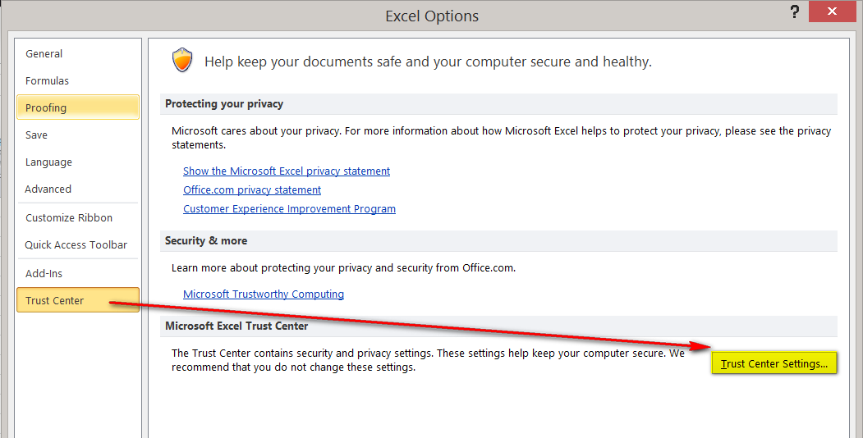

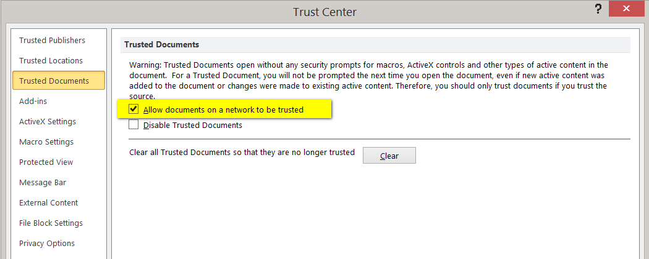

For Win7 users: Under Trust Center Settings > Locations, select "Add new location" then select "The Sub -Folders of this location are Trusted" > click Browse and locate the following folder to add: C:\ProgramData\QuoteMedia\resources\nativelibs

For Win8 and Win10 users: Under Trust Center Settings > External Content, select > Enable all Data Connections – and > Enable automatic update for all Workbook links

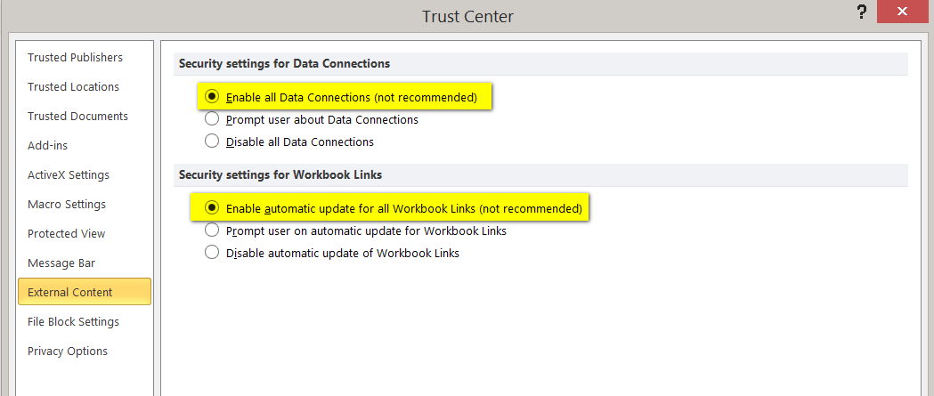

Under Trust Center Settings > ActiveX Settings > Select “Enable all Data” and “Enable automativ update for all Workbook links”

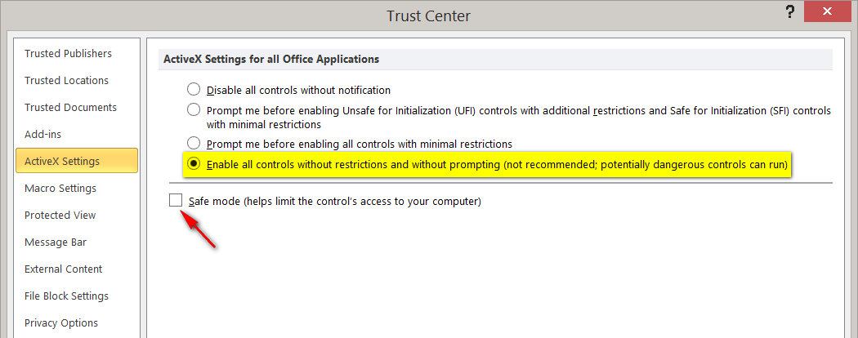

Under Trust Center Settings > Macro Settings > Select “Enable all Macros”

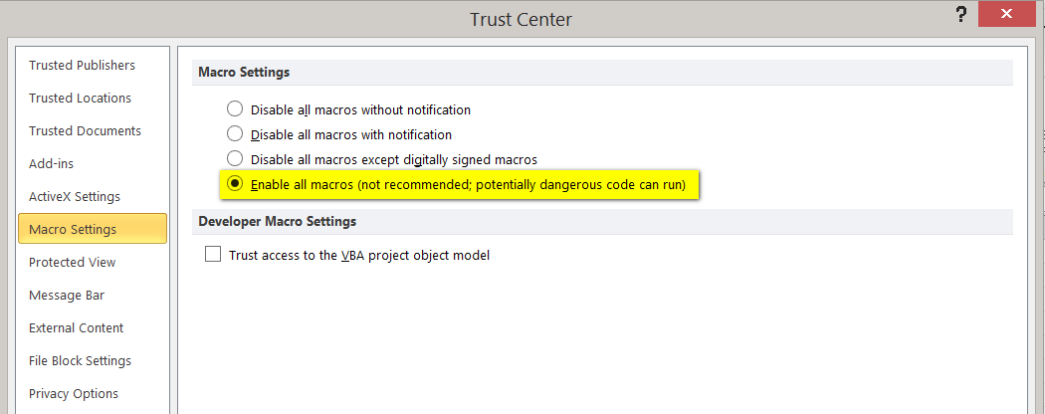

Step 4

Update Java and clear Java cache: https://www.java.com/en/download/help/plugin_cache.xml

Step 5

Update Windows User Control Settings; lowering controls to “Never Notify” has solved problems in the past. http://windows.microsoft.com/en-ca/windows7/how-do-i-change-the-behavior-of-user-account-control-by-using-the-slider

Step 6 (Not Applicable for Desktop version of Quotestream)

Ensure that Java is running in the appropriate bit version to your version of Quotestream and Microsoft Excel. It is possible to have the 32-bit and 64-bit versions of Java on your computer at the same time and your computer may choose to use the version 64-bit of Java even though you are running the 32-bit version of Quotestream and Microsoft Excel. First confirm which versions of Java that you have by going into ‘Configure Java’ which you can type into your Windows search area, or finding in the ‘Java’ folder in your Start Menu.

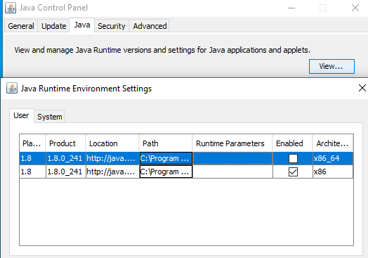

First, click on the ‘Java’ tab up at the top and then on the ‘View’ button to the right as shown in the picture above. You can tell the bit version of Java that you have by looking in the very far right column under Architecture, the ‘x86_64’ is the 64-bit version while the ‘x86’ version is the 32-bit version.

If you are missing the need bit version of Java then you can download it from this website: https://www.java.com/en/download/manual.jsp

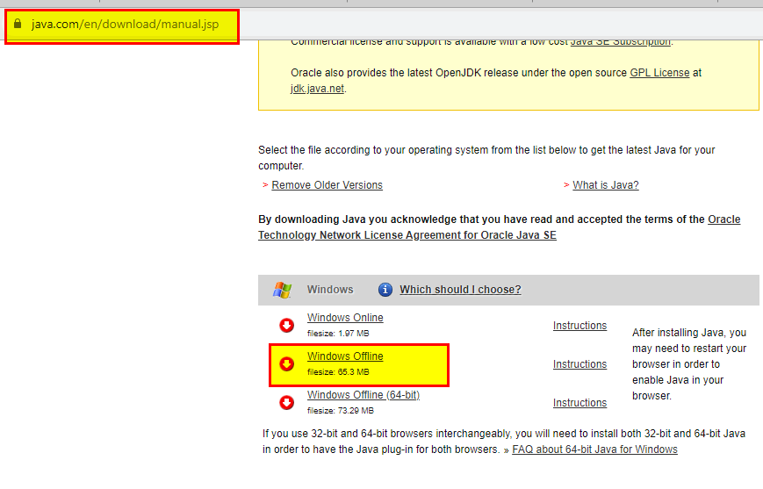
Highlighted in the picture above is the 32-bit Java version, so select that one if it is the one you are missing or select the one below is for the 64-bit Java version. Then after you download and install it, you can bring up the Configure Java program again and this time select the correct bit version of Java you want to have running.

Frequently-Asked Questions (FAQ)
- What do I need to install to use RTD?

You do not need to install any additional software. All you have to do is log on to Quotestream. Quotestream does all the setup and configuration for you in the background.

- The quotes appearing on the Excel spreadsheets seem to update only every two seconds – how can I get the spreadsheet to update faster?

Excel RTD is set to update every 2 seconds by default. This is called the Throttle Interval. You can change the default Throttle Interval in Excel by going to Tools → Macro → Visual Basic Editor. From the Visual Basic Editor, go to View → Immediate Window. On the Immediate Window, type in

Application.RTD.ThrottleInterval=0

and press Enter. Setting the Throttle Interval to 0 means that the spreadsheet is refreshed as soon as there are updates.

Click here for more information on the Throttle Interval.

- I am getting #N/A when I open my RTD spreadsheet, what should I do?

Check that you are properly logged on and getting streaming data on Quotestream.

If you are using Windows, see “For Windows Users” section of this document.

- I am getting Invalid Field: OUTPUTNAME when I try a new data output that was mentioned in the latest release, why is that?

Ensure that your version of Quotestream Desktop has been updated to the latest version. Inside the Quotestream Desktop application, in the menu bar, you will see an option to update to the latest version if you have not done so already.

You can also download the version of Quotestream Desktop available here: https://quotestream.com/download/

Note that you must ensure that your Quostream Desktop version matches the same 32 or 64-bit versions of your Microsoft Excel.

