Quotestream Professional DDE (Dynamic Data Exchange)

How to Use DDE?
Data Point Coverage
Data Point Format
System Requirements
Troubleshooting

Quotestream’s DDE functionality provides you with streaming dynamic, real-time quotes using a Windows protocol which allows applications to exchange data.

This powerful tool greatly extends your control, whether you simply prefer to view live market data in a spreadsheet, or wish to perform specialized calculations and use specific third-party features or applications for charting, data aggregation, conditional formatting, macros, etc.

As data updates in Quotestream, the same data updates accordingly in your third-party application, embedded in streaming real-time. Summary of Features for DDE functionality (DDE Plugin):

• User-definable DDE server/topic/item for each field (open, high, low, close, volume, trade size, total volume, bid, bid size, ask, ask size, time)

• Supports up to 500 streaming symbols in real time if account is entitled to this number of symbols in Portfolio Manager.

• Supports Real-Time data interval if account is entitled to real-time data.

• No backfill of data available as this is an intraday service.

With Quotestream’s DDE, you can track a wide range of stock market statistics, from basic stock quote data (last price, volume, change, bid, ask) to price statistics (52-week high, 52-week low) and valuation parameters (earnings per share, PE ratios, dividend yields).

Having troubles connecting to the service?
Please see further on in this document for trouble shooting tips.

How to use DDE?

Connecting DDE functionality with another third-party application will have its own configuration steps to follow depending on the application providers’ protocols, etc. Quotestream’s DDE-compliant functionality (DDE Plugin) is provided on an "as-is" basis. No additional support is provided with respect to configuring our DDE service with third-party applications.

You must be logged into Quotestream to set a session and receive streaming data at the level of entitlements that your Quotestream application is set to receive, i.e, those exchanges for which you have real-time entitlements will stream in real-time into the third-party application.

QuoteMedia’s Quotestream DDE feature implementation takes advantage of the DDE (“Dynamic Data Exchange”) and OLE (“Object Linking and Embedding”) compound document standards developed by Microsoft Corporation. These standards allow the creation of objects in one application to be linked or embedded in a second application. Embedded objects retain their original format and links to the application that created them.

Examples:

The formula for OpenOffice Calc would resemble =DDE("quotestream";"AAPL:US";"Last").

Most documentation of DDE uses DDE syntax which looks as follows: =SERVER|TOPIC!ITEM

There are 4 parts to a DDE function:

1. DDE Function Call – this is how the application knows that you are calling a DDE function.

2. DDE Server Name – the name of the DDE server where the function gets processed. In this case, the value is “quotestream".

3. Stock Symbol – a symbol of a stock or other financial instrument.

Note: Symbols containing an @ (ie - options symbols) must be escaped with a single quote.
For example, @APVIN needs to be entered into Excel as '@APVIN

4. Data Point – the data point you wish to request (see “Data Points” below).

You can download Sample DDE OpenOffice Spreadsheets from this page:

http://www.quotestreampro.com/RTDdocs

Data Point Coverage

Quotestream DDE supports the following data points:
Last Price | Volume | Close Price | Currency
Change | Trade Value | Open Price | Dividend
Percent Change | VWAP | 52 Week High | Yield
Bid Price | Last Trade Time | 52 Week Low | Ex-Div
Bid Size | Last Trade Size | 52 Week High Date | Earnings Per Share
Ask Price | High | 52 Week Low Date | PE Ratio
Ask Size | Low | Previous Close | P/B Ratio
TRIV (TSX Indices) | Marketplace | TWAP | Shares Outstanding
Symbol | Tick | Description | Market Cap
Average Volume 10 Day | Tick Volume | Pre Market Last | Exchange
Average Volume 20 Day | Performance 3 Month | Pre Market Change | Post Market Last
Average Volume 30 Day | Performance 1 Month | Pre Market Percent Change | Post Market Change
Average Volume 50 Day | Performance 6 Month | Post Market Percent Change | Pre Market Volume
Average Volume 90 Day | Performance 1 Year | Pre Market Trade Time | Post Market Volume
Average Volume 100 Day | Sector | Post Market Trade Time | Industry
Average Volume 365 Day | Alpha | Beta | R-Squared
Standard Deviation | YTD% | Short Sale Restriction | SubIndustry
Performance 3 Year Annualized | Performance 3 Year Cumulative | Performance 5 Year Annualized | Performance 5 Year Cumulative
Performance 10 Year Annualized | Performance 10 Year Cumulative | Implied Volatility | Implied Volatility Change
21 Day Moving Average | 50 Day Moving Average | 200 Day Moving Average | Open Interest
Mark | Previous Mark | Mark Change Percent | Mark Change
Intrinsic Value | Extrinsic Value | Bid Implied Volatility | Ask Implied Volatility
Delta | Gamma | Theta | Vega
Rho | Enterprise Value | Return on Capital | Return on Equity
Return on Assets LTM | Return on Capital LTM | Return on Equity LTM | Return on Assets
Return on Invested Capital QTR | Return on Invested Capital 1YR | Post | Panel
Firm Name | Next Earnings Date | Earnings Quarter End

Data Points

Data Points are available in long or short form for your convenience. Either may be used.

For example:

=DDE("quotestream";"MSFT:US";"Last Trade Time")

… will return the same result as…

=DDE("quotestream";"MSFT:US";"LTime")

Long Name | Short Name | Long Name | Short Name
Symbol | Symbol | Description | Desc
Last Price | Last | Change | Chg
Percent Change | PChg | Last Trade Time | Ltime
Last Trade Size | LSize | Bid Price | Bid
Ask Price | Ask | Ask Size | Asize
Bid Size | Bsize | Open Interest | Int
Volume | Vol | 52 Week High | 52wHi
Yield | Yld | 52 Week Low | 52wLo
Dividend | Div | Ex-Div | ExD
Earnings Per Share | EPS | PE Ratio | PER
P/B Ratio | PBRAT | Exchange | Exch
Marketplace | Market | Currency | Curr
Tick | Tick | Low | Lo
Open Price | Open | High | Hi
Previous Close | PClose | Close Price | Close
TRIV | TRIV | Shares Outstanding | SHOS
Market Cap | MCap | Volume Weight Average Price | VWAP
TWAP | TWAP | Pre Market Last | PreLast
Pre Market Change | PreChg | Pre Market Percent Change | PrePChg
Pre Market Volume | PreVol | Pre Market Trade Time | PreLtime
Post Market last | Post Last | Post Market Change | PostChg
Post Market Percent Change | PostPChg | Post Market Volume | PostVol
Post Market Trade Time | PostLTime | Value | Val
TICKVOLUME | Tvol | Performance 1 Month | P1M
Performance 3 Month | P3M | Performance 6 Month | P6M
Performance 1 Year | P1Y | Mark | Mark
Previous Mark | PMark | AVERAGE VOLUME 10 DAY | AV10D
AVERAGE VOLUME 20 DAY | AV20D | AVERAGE VOLUME 30 DAY | AV30D
AVERAGE VOLUME 50 DAY | AV50D | AVERAGE VOLUME 90 DAY | AV90D
AVERAGE VOLUME 100 DAY | AV100D | AVERAGE VOLUME 365 DAY | AV365D
52 Week High Date | 52wHiD | 52 Week Low Date | 52wLoD
Sector | SCT | Industry | IND
SubIndustry | IND2 | Alpha | Alpha
Beta | Beta | R-Squared | R2
Standard Deviation | Stddev | YTD% | YTD%
Performance 3 Year Annualized | P3YA | Performance 3 Year Cumulative | P3YC
Performance 5 Year Annualized | P5YA | Performance 5 Year Cumulative | P5YC
Performance 10 Year Annualized | P10YA | Performance 10 Year Cumulative | P10YC
Short Sale Restriction | regSHO | 21 Day Moving Average | MA21
50 Day Moving Average | MA50 | 200 Day Moving Average | MA200
Enterprise Value | EV | Return on Capital | ROC
Return on Equity | ROE | Return on Assets | ROA
Return on Capital LTM | ROCLTM | Return on Equity LTM | ROELTM
Return on Assets LTM | ROALTM | Return on Invested Capital QTR | ROICQTR
Return on Invested Capital 1YR | ROIC1YR | Post | Post
Panel | Panel | Firm Name | Firm Name
Next Earnings Date | NextEarnDate | Earnings Quarter End | EarnQuartEnd

System Requirements

DDE requires a Windows machine.
This service is not supported in MS Excel which would require that you use RTD.

Trouble Shooting

If you are having trouble connecting to the service, please try the following steps:

For Windows Users

- The Operating System, the version of Quotestream and the version of Java must be the same. If using OpenOffice, note that OpenOffice only comes in 32-bit, meaning that both Quotestream and Java (if using webstart version) must be 32-bit.

Quotestream can be downloaded from https://www.quotestream.com/download/

Java can be manually downloaded from https://www.java.com/en/download/manual.jsp (make sure to download the Windows version that is not 64-bit)

- Allow permissions to Java through your firewall, possibly both public and private depending on where you are accessing the application from. This Both a Windows and a third party firewall service should be adjusted to allow Excel and Java access.

- For Win7 users: Under Trust Center Settings > Locations, select "Add new location" then select "The Sub -Folders of this location are Trusted" > click Browse and locate the following folder to add: C:\ProgramData\QuoteMedia\resources\nativelibs

- For Win8 and Win10 users: Under Trust Center Settings > External Content, select > Enable all Data Connections – and > Enable automatic update for all Workbook links

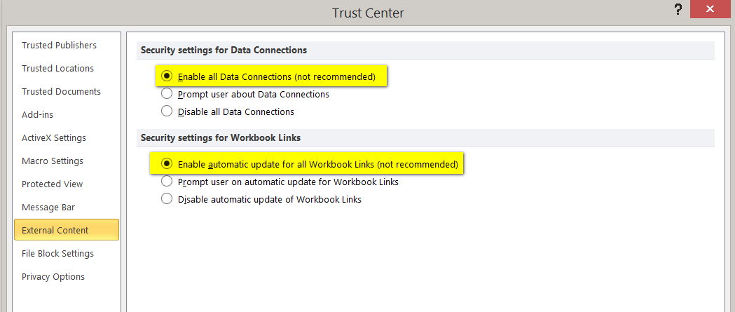

- Under Trust Center Settings > ActiveX Settings > Select “Enable all Data” and “Enable automativ update for all Workbook links”

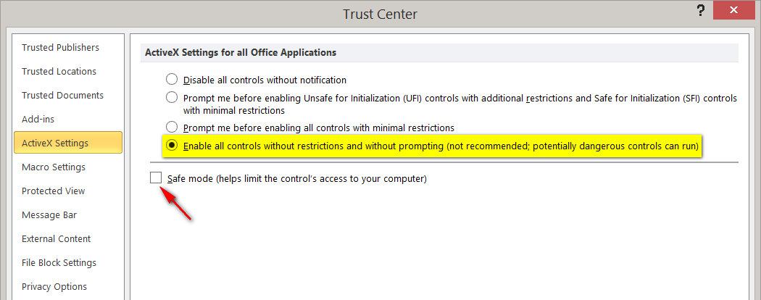

- Under Trust Center Settings > Macro Settings > Select “Enable all Macros”

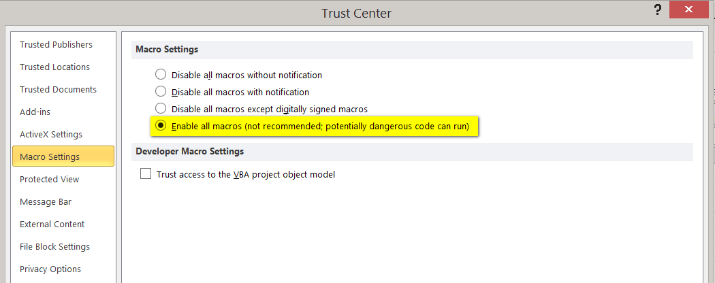
- Update Java and clear Java cache: https://www.java.com/en/download/help/plugin_cache.xml

- Update Windows User Control Settings; lowering controls to “Never Notify” has solved problems in the past. http://windows.microsoft.com/en-ca/windows7/how-do-i-change-the-behavior-of-user-account-control-by-using-the-slider

Reminder:

Ensure that your version of Quotestream Desktop has been updated to the latest version. Inside the Quotestream Desktop application, in the menu bar, you will see an option to update to the latest version if you still need to do so.

You can also download the version of Quotestream Desktop available here:
https://quotestream.com/download/

Note that you must ensure that your Quostream Desktop version matches the same 32 or 64-bit versions of your Microsoft Excel.

